An Autism diary app:

A 2011 study[1] on those with a diagnosis of Autism Spectrum Disorder found that “Individuals with autism frequently fail to react appropriately to the emotions of others, and researchers have suggested that an impairment in emotional expression recognition may contribute to these inappropriate reactions and to their understanding of emotion in general.”(p.1). From my personal experience and based on the data of the 3 groups in the study, it is my opinion that the reason is not because of a lack of desire or complete cognitive inability. Rather it is the lack of a mental and emotional framework which most people get through the traditional developmental processus. Those with ASD (whether it is because they are high functioning or cognitively impared) are not able to fully participate qualitatively in the traditional social development processus. If ~~they~~ we want to grow, we must develop our own methods and processes in order to find some measure of success.

Basic plot diagram:

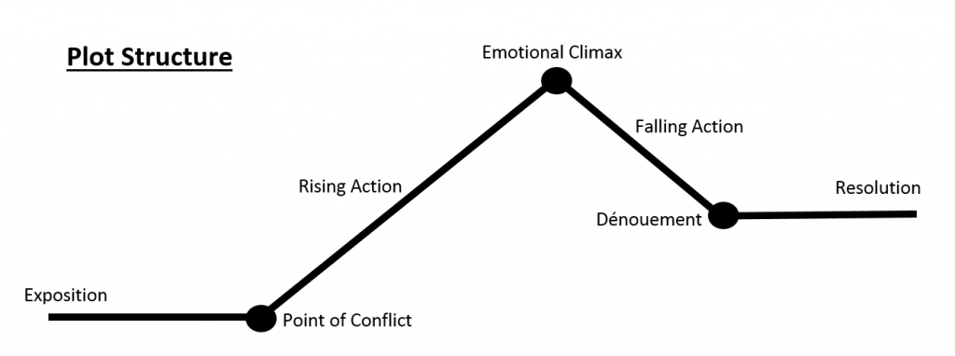

* Each journal entry follows a modified structure of a plot diagram to help those on the autism diagram articulate complex and intense feelings.
* User login/password
* Journal features :
  + Date/time is automatically integrated
  + 1. Intro. Situation, problem, etc.
    - Emoji selection how you feel…. About this section.
  + 2. The context. What was the context, what were your mistakes, others mistakes, etc.
    - Emoji selection how you feel…. About this section.
    - Brief string. Why you choose this emoji
  + 3. Climax. The trigger of the height of your most intense emotions. What did you do, what were your most negative thoughts?
    - Emoji selection how you feel…. About this section.
    - Larger string. Why you choose this emoji
  + 4. Acceptance. Whether or not you are there or not. The user must struggle to get here. Type what they will do to get to acceptance.
    - Form
    - Emoji selection
  + 5. Concluding thoughts [2]: limit the text area. How to get to peace.
  + Calendar (extra module)
  + Ability to attach images. [3] (stretch) (extra module)
  + Ability to attach an audio recording. [4] (stretch) (extra module)
* Entries have a date
* Show more recent first
* Store them in a database.
* Have a calendar model / function (sort by date) ]

1. <https://www.ncbi.nlm.nih.gov/pmc/articles/PMC3085906/pdf/nihms284393.pdf>
2. <https://www.tutorialspoint.com/How-to-limit-the-number-of-characters-entered-in-a-textarea-in-an-HTML-form>
3. Limit to 3
4. <https://www.npmjs.com/package/node-audiorecorder>